# The Education of a Queen

**Princess Elizabeth will be eighteen on her next birthday. How does her education compare with that of an American girl of the same age? And how does it compare with that of Victoria, who was also educated to be queen?**

**By**[**Wilson Harris**](https://www.theatlantic.com/author/wilson-harris/)

**The Atlantic, December 1943**

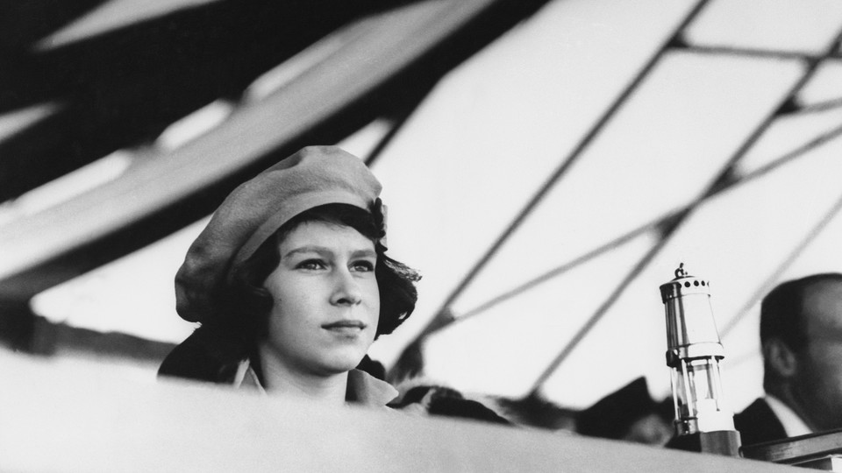

*Princess Elizabeth pictured at age 16 in 1942 (AP)*

### 1

The people of Britain are beginning to take it a growing interest in the personality of their future Queen—only beginning, because so far Princess Elizabeth's life has most rightly been spent in her home rather than in the public eye, and her future subjects know relatively little of her, apart from the admirable broadcast talk she gave some three years ago to the children of the Empire, at home and overseas, when she was only fourteen. Now that the Princess stands on the threshold of public life, both they and persons in other lands who watch the fortunes of the British Royal House may feel some natural desire to know how she is being prepared for the high office that will one day be hers; and the Queen has shown a gracious readiness to make available such information as is requisite for that purpose.

It is more than a century, though not much more, since a girl of seventeen stood first in succession to the Throne, and some comparison between the heir-presumptive of that day and the heir-presumptive of this is not only inevitable but instructive. What part Princess Victoria's native qualities, and what part the training she received, played respectively in fitting her for the great responsibilities she so greatly sustained is not to be precisely estimated. What is certain is that, with one arguable exception, she was the greatest Queen Britain has known, and one of its greatest sovereigns.

Yet in all but one respect—a childhood shadowed by a war which has cut off the opportunity of foreign travel at an age when its educational value would be great—the advantage is with the Princess of today. First and foremost, she is far more fortunate in her parentage and early surroundings. The Duke of Kent, Princess Victoria's father, had his qualities, but all his associations were German, and his wholly German wife was a well-meaning but limited woman. The secluded household at Kensington, then well outside London, was permeated by the influence of the German Fraulein Lehzen, the German Prince Leopold (the Duchess of Kent's brother), and the half-German Baron Stockmarnot—not the happiest atmosphere for the nurture of a Queen.

Princess Elizabeth was born in a house in a London street, and spent most of the first ten years of her life in a house in another London street, Piccadilly, with cars and buses and taxis—all that makes up the swift and shifting life of London speeding ceaselessly past its windows day and night. It was the comfort of an English home like a thousand others, rather than the luxury, or imagined luxury, of a palace. There the Princess was taught to read by her mother. Till she was seven her education was confined to reading and writing (Princess Victoria was tutored in the latter by the writing-master of Westminster School), French, the piano, and dancing. Then Miss Crawford, Scottish, an Edinburgh graduate, well-traveled, a lover of fresh air and exercise, was brought south to institute a very different tutelage from that exercised over the Princess of the 1820's by Fraulein Lehzen.

But King George's two daughters—for Princess Elizabeth is happily not, like Princess Victoria, an only child—are well-provided also with teachers of special subjects, such as French, German, and music. Princess Elizabeth today reads history with the Vice-Provost of Eton, on the basis of such works as Trevelyan's History of England, which could not be improved on, and Muzzey's History of the United States (how many English girls of seventeen read any American history at all?), together with European history in outline. In Biblical history Canon Crawley, of St. George's Chapel, Windsor, has been her guide. A natural linguist, she speaks French and German fluently and with an excellent accent. She has read some Moliere, some Corneille, some Daudet, and she knows many of "Les Cent Meilleurs Poemes Francais" by heart.

The Princess's explorations in the field of English literature are of greater interest and perhaps of greater significance. Time for reading at large is limited, for the formal educational regimen is treated seriously. But in or out of "school hours" she has read most of Shakespeare; The Canterbury Tales; a good deal of Coleridge, Keats, Browning, and Tennyson; some of Scott, Dickens, Jane Austen, Trollope, and Robert Louis Stevenson; while in lighter moments she turns to Conan Doyle (I hope The White Company as well as Sherlock Holmes), John Buchan (I hope Montrose as well as Greenmantle), and, before he brought dishonor on his name, P. G. Wodehouse (whose hold was as potent over a Prime Minister of seventy as over a Princess not seventeen).

That is a wide and wholesome range that would provide a sound basis of literary knowledge and taste for any girl in her last year of school. Compare Princess Victoria writing (when on the verge of seventeen) to Uncle Leopold about Sully's Memoirs, in which she finds "a great deal that applies to the present times," and, a little earlier, about Russell's Modern Europe and Clarendon's History of the Rebellion. The advantage again is with our Princess of today.

But life has more sides than the literary, and no picture of the Princesses Elizabeth and Margaret would be just if it neglected the delight they take in riding and swimming, in music and singing, in holidays on the moors round Balmoral and—at the spot in the country to which they moved from London early in the war—the production of a pantomime, an enterprise which has been both achieved and repeated. Here in some respects heredity can be traced; Princess Victoria was a skillful horsewoman, a good musician, and a singularly keen dancer. But there is no reason to suppose that she was a swimmer, and much reason to suppose that she was not. Princess Elizabeth was professionally taught, passed her life-saving tests and gained her badges at the Bath Club, and finds water—with pennies to dive for and the crawl stroke to practice—a hardly less natural element than air.

As is generally known, she was a Guide (the girls' equivalent of Boy Scouts) for years—till the war as member of a company composed mainly of children living in the Royal Mews at Buckingham Palace, and since then in the country, where local children, and others from an evacuated school, form the nucleus. Now the Princess is a Sea Ranger—most Guides become Rangers when they are about sixteen—and gets manifest interest and enjoyment from the weekly meetings. The scope of the Rangers is wide. A system of war training has been developed, known as the Home Emergency Service, which includes First Aid and Home Nursing, Child Welfare, and various forms of Civil Defense. Princess Elizabeth is concerning herself particularly with the last, and acquiring incidentally a good all-round knowledge of electricity.

She listens regularly to the radio and follows the war news closely. In that connection another parallel suggests itself. "Strong sympathy with the Army is a main characteristic of her career," wrote Sir Sidney Lee of the Princess Victoria. "Another trait in the Princess's character," writes one who knows Princess Elizabeth well, "which certainly comes down through generations on the King's side, is her love of the Army and its tradition"—in particular, naturally, of the Grenadier Guards, of which she is Colonel.

### 2

Such has been and is the childhood of Britain's future sovereign. As has been said, it is right that her future subjects and others should know something of it, enough to assure them that the Princess is being fitted in body and mind against the day—still, it may be hoped, far distant—when the vast responsibilities that attach to the headship of the British Commonwealth will rest on her. A constitutional sovereign's office is no sinecure. There are always State papers to master. Decisions of great moment may be called for. Resignations of Ministries have to be accepted, involving an invitation to someone, not always plainly indicated by circumstance, to form a new Cabinet. King George V, the moment he succeeded, had to grapple with an acute political controversy.

These are not contingencies for which a girl of seventeen can or ought to be specifically prepared. It is enough that she should acquire a working knowledge of the history and constitutional practice of her country, and that her character should develop a quiet strength that can be drawn on as need arises. But that belongs to the Princess's inner life, about which it would be an impertinence to say a word.

Of her outer life we know something—as, for example, that she was confirmed at Windsor in March of last year—and we shall know more as the moment approaches when she will be appearing more often with her parents, or even without them, on public occasions. If it be asked, as it well may be, how the Princess's official coming-of-age when she is eighteen, next April, will be commemorated, the answer is, I believe, that no decision at all about that has yet been taken.

A great deal will depend on whether Britain is still at war in Europe. Precedent does not help much in any case. On the like occasion in time Princess Victoria's life the celebrations took place in the village of Kensington, where she spent her childhood. The Corporation of the City of London presented an address to her, and the King gave her a grand piano and a State ball (which he did not attend himself). He also offered her an independent household, but her mother promptly vetoed the idea. It may be taken as certain that, no question of that will arise in Princess Elizabeth's case. Family ties are strong in the British Royal House, and she is not likely to separate herself from her parents while they both live, except in one eventuality, of which there is no sign or suggestion yet—a marriage which in the unfolding of time will give Britain a Prince Consort again.

Legislation under process of being enacted provides that the Princess may, as soon as she reaches the age of eighteen, sit on a Council of State such as is appointed to discharge the King's functions whenever the sovereign himself is absent from the Kingdom.

That relatively little has been known of the Princess hitherto is matter for satisfaction rather than regret, for it means that her childhood has been wisely guarded and sheltered, and her personality allowed to develop as it would, unstrained by any undue consciousness of status. The "fierce light which beats upon a throne" probably oppresses King George, and oppressed his father, little; but youth should be spared that white illumination so far as may be. The Princess may have years of service as heir-presumptive before her. She may at any moment by the caprice of fate be summoned to the most exalted position in the greatest Commonwealth in the world. Enough is known of her upbringing to show how well the preparation for either lot has been achieved by a training that has never threatened to dim the freshness or mar the simplicity of her girlhood.

<https://www.theatlantic.com/magazine/archive/1943/12/the-education-of-a-queen/306470/>